Dis-Bulgaria-Neolithic-Ceramic-Figurine-Abstract-VI Millennium BCE- Stara Zagora-92 mm

Case 1

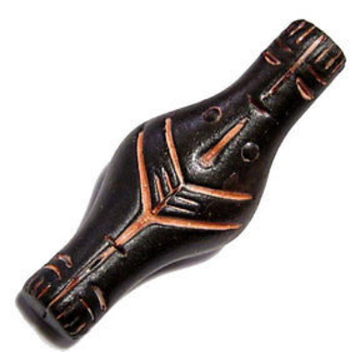

**Size: 92/37mm;                Weight: 28 g;**